Problem #1

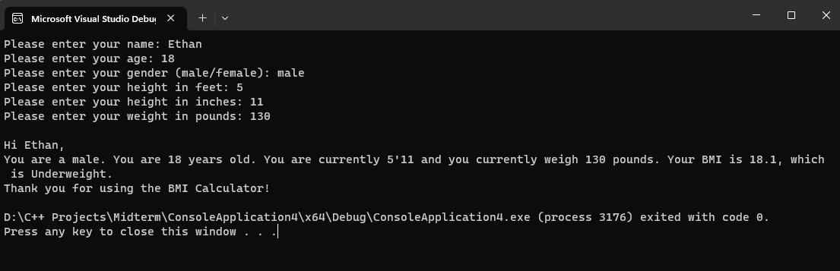

Problem #2 (Some of the links provided were not working at the time of doing this)

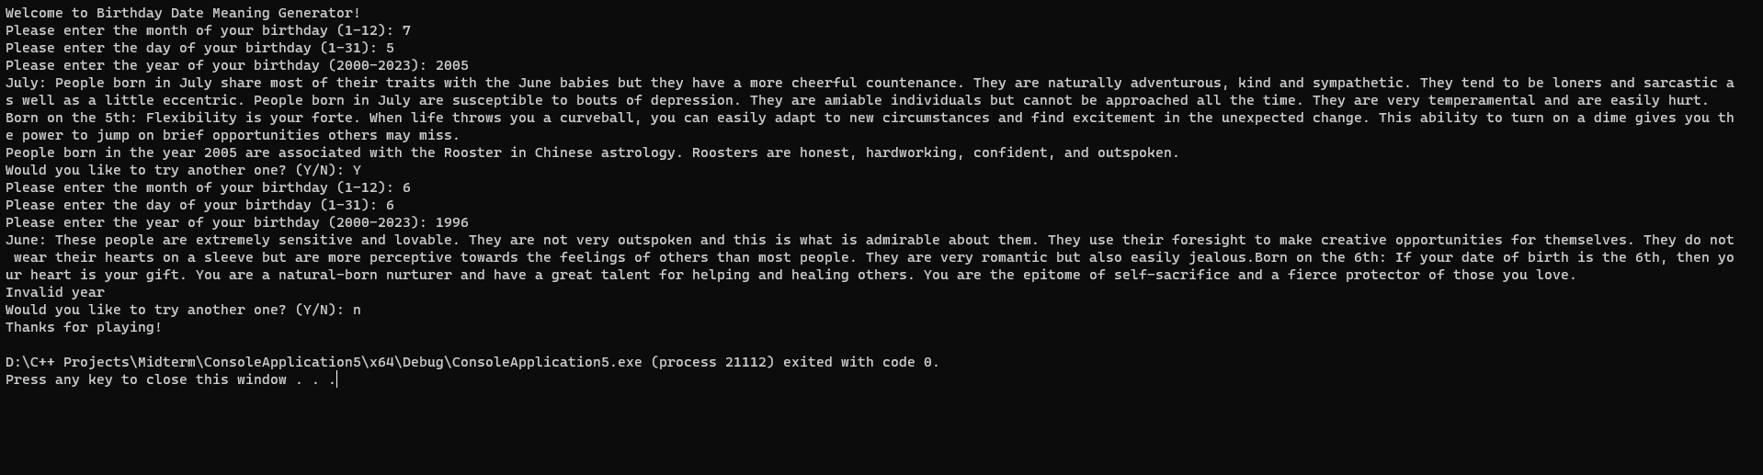

Problem #3

